EDMONSON COUNTY PRIDE TSHIRT ORDER FORM HELPING SANTA’S SECRET HANDS
MAKE CHECKS PAYABLE TO: STUDIO DD, 52 CHAPEL CENTER LN, SMITHS GROVE KY, 42171

TSHIRT STYLE SIZE CHOICES NAME/SHIPPING ADDRESS
76 STATE CHAMPS S M L XL 2X 3X 4X
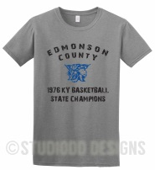PRICE PER SHIRT $16 $16 $16 $16 $18 $19 $20 TOTALS:
BULLDOGS S M L XL 2X 3X 4X
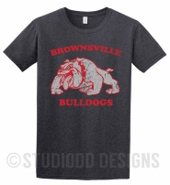 PRICE PER SHIRT $16 $16 $16 $16 $18 $19 $20 TOTALS:
NAT’L ANTHEM S M L XL 2X 3X 4X
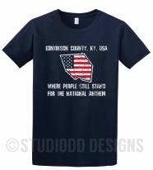 PRICE PER SHIRT $16 $16 $16 $16 $18 $19 $20 TOTALS:
KYROCK S M L XL 2X 3X 4X
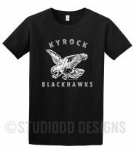 PRICE PER SHIRT $16 $16 $16 $16 $18 $19 $20 TOTALS:
SQUADGOALS S M L XL 2X 3X 4X
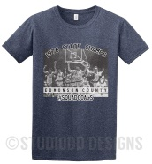 PRICE PER SHIRT $16 $16 $16 $16 $18 $19 $20 TOTAL AMOUNT ENCLOSED:

